Report on Assignment 6
Task 1
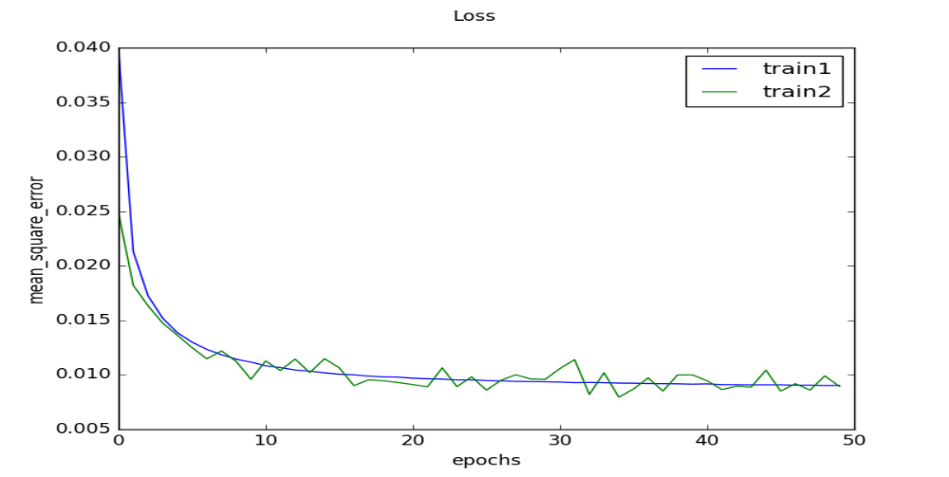
  - Fig 1.1 mean square error vs the no of epochs
Task 2
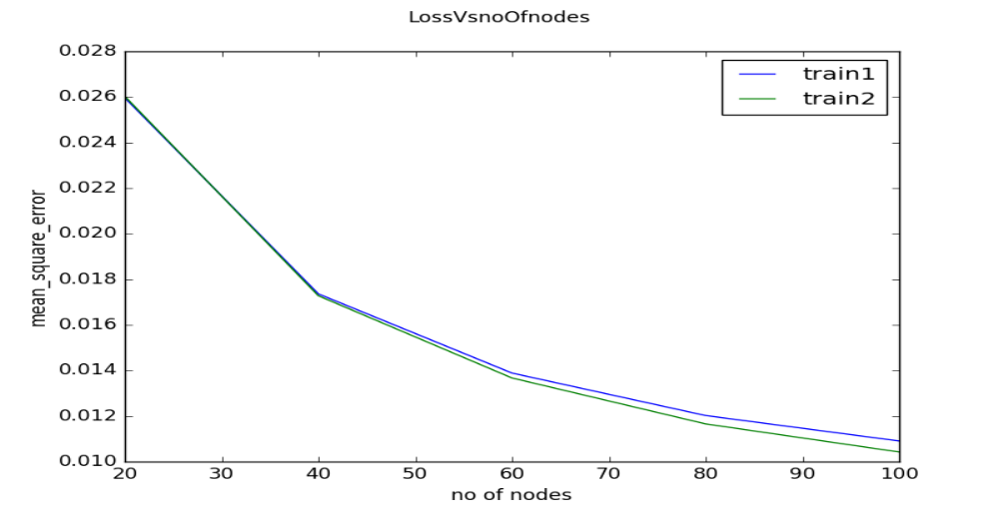
Fig 2.1 mean square error vs the number of nodes in hidden layer

Task 3
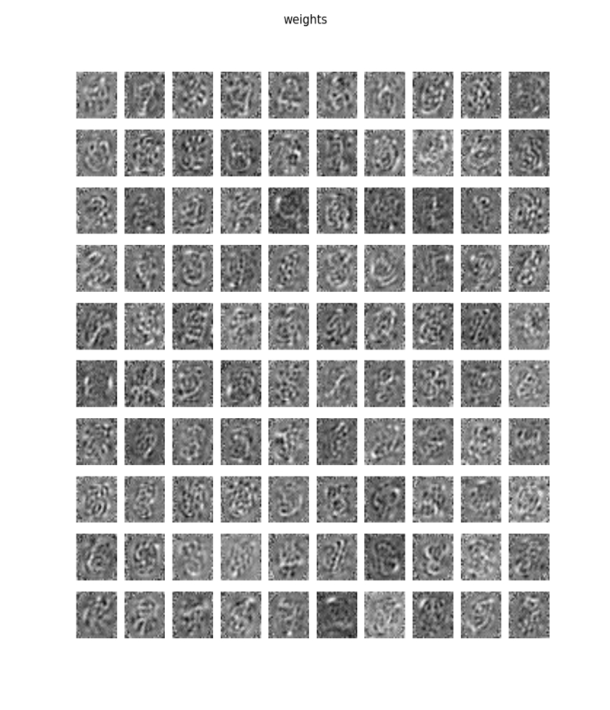
Fig 3.1 grid of learned weights

Task 4
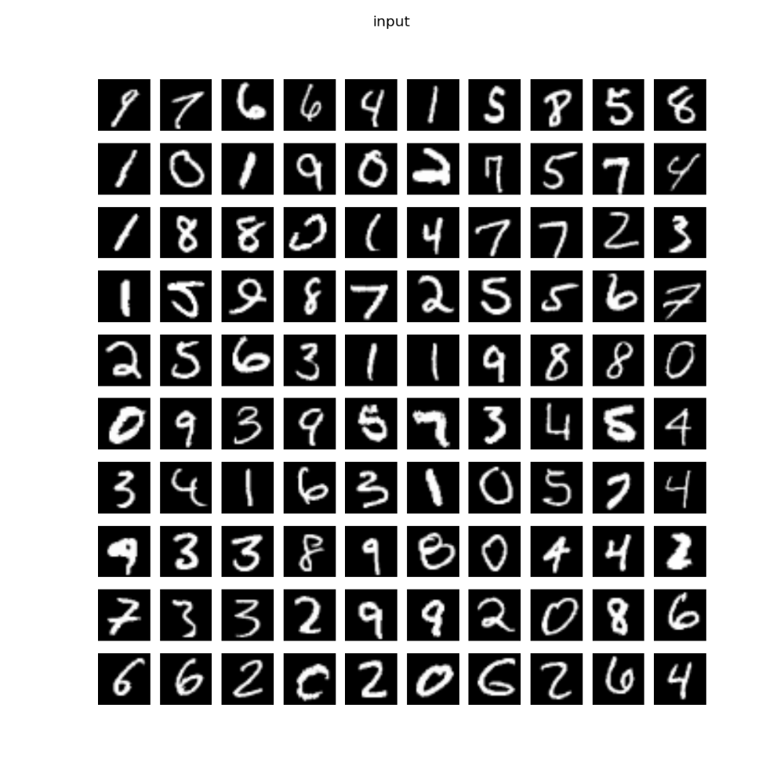
Fig 4.1 grid of the input

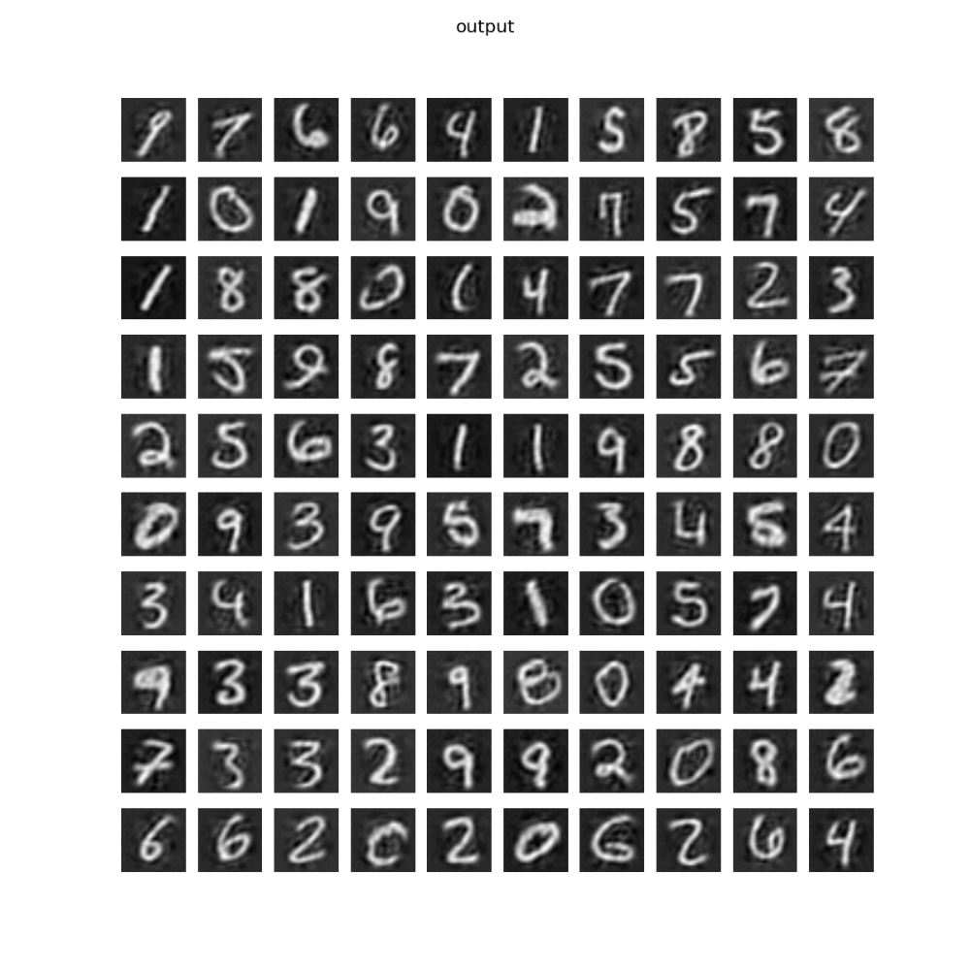
Fig 4.2 grid of the output

Task 5
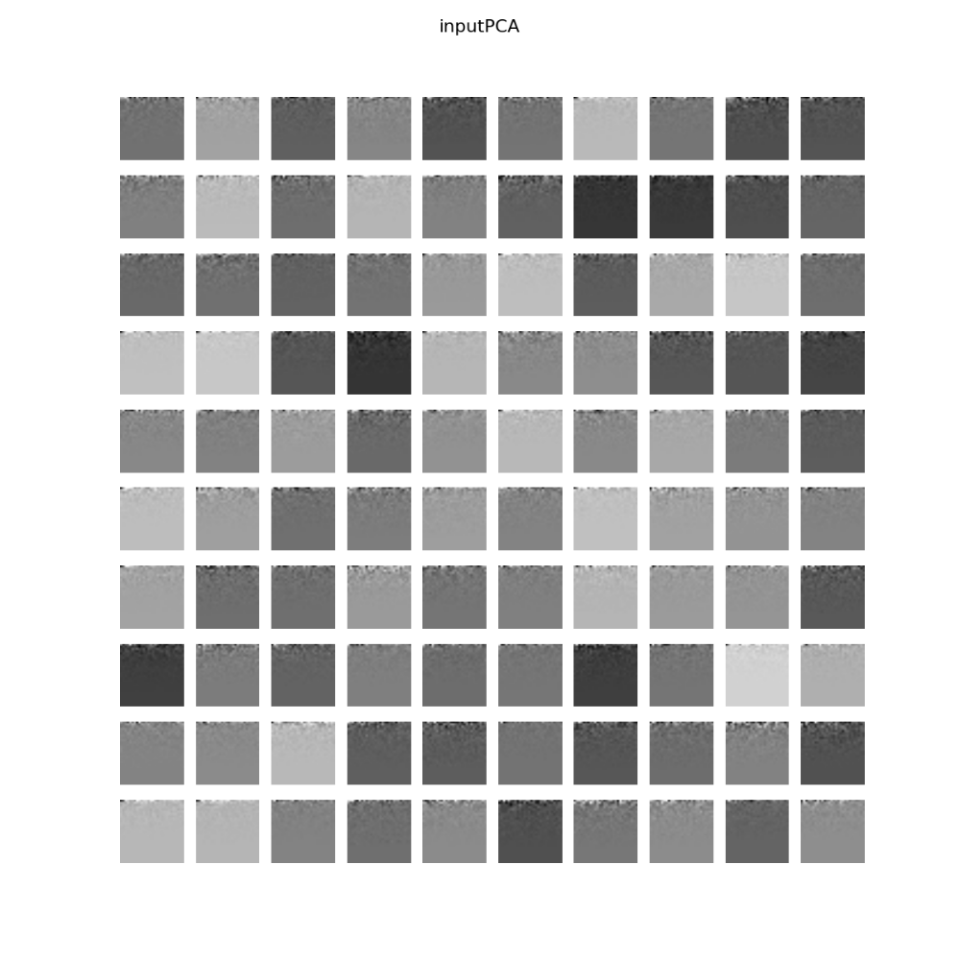
Fig 5.1 grid of the input PCA

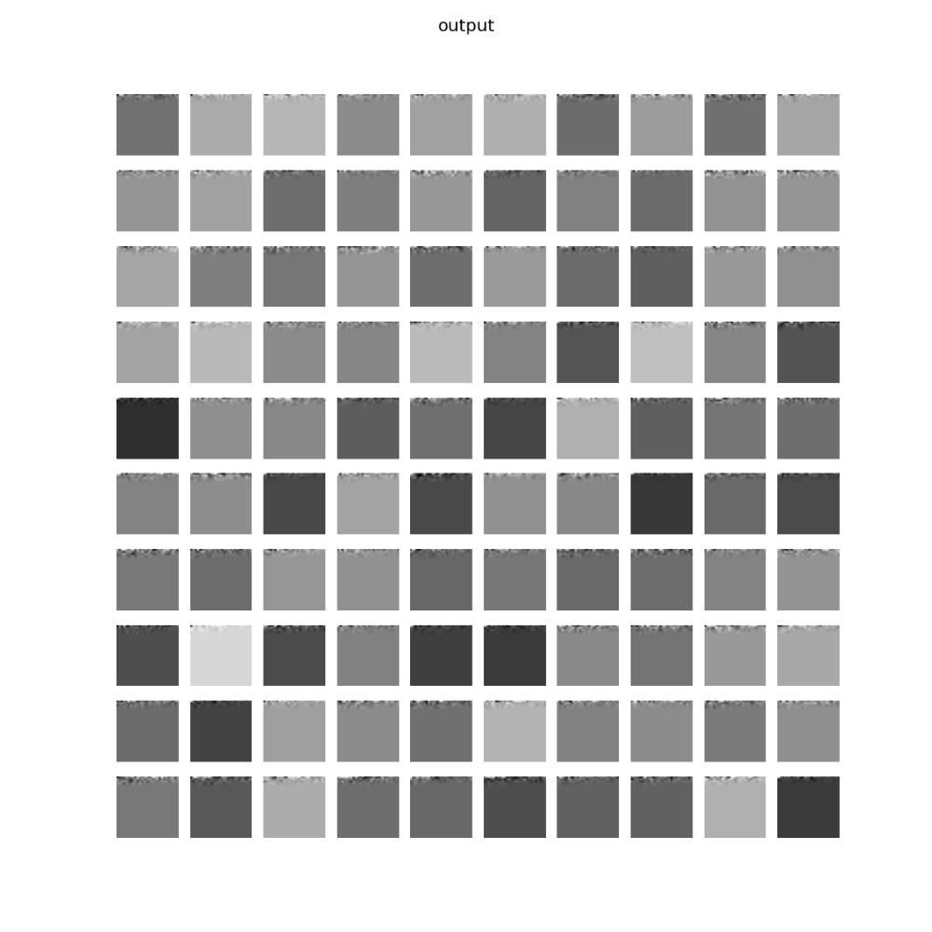
Fig 5.2 grid of the outputPCA

